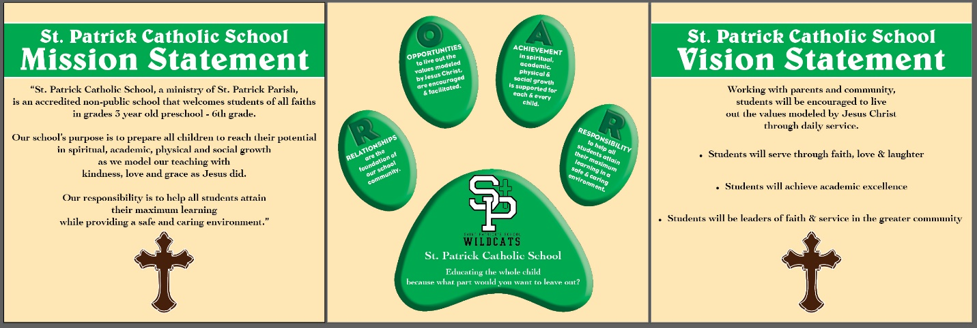

St. Patrick Catholic School Scholarship
Allamakee Scholarship Fund

One (1) $500 Scholarship is to be awarded to a graduating senior who attended St. Patrick School in Waukon, Iowa. Students who meet the criteria for the St. Patrick School Scholarship and the Allamakee Scholarship Fund will be considered for the scholarship.

Applicants do NOT have to be Catholic or members of St. Patrick Parish; however, the applicants must have attended St. Patrick School during his/her school year.

The application must be completed and returned to Waukon High School Guidance Office by the deadline of January 31.

Scholarship Criteria

Student Name: ___________________________ Applicant #________

- Attended St. Patrick School the from _________grade to _________grade.

- On a separated sheet of paper write a 200-300 word essay describing:

  - How My Attendance at St. Patrick School Shaped My Lifetime Values and Morals.
(Please attach the essay to this cover letter. DO NOT include your name on the essay letter.)

Thank you for submitting your application! God Bless!

