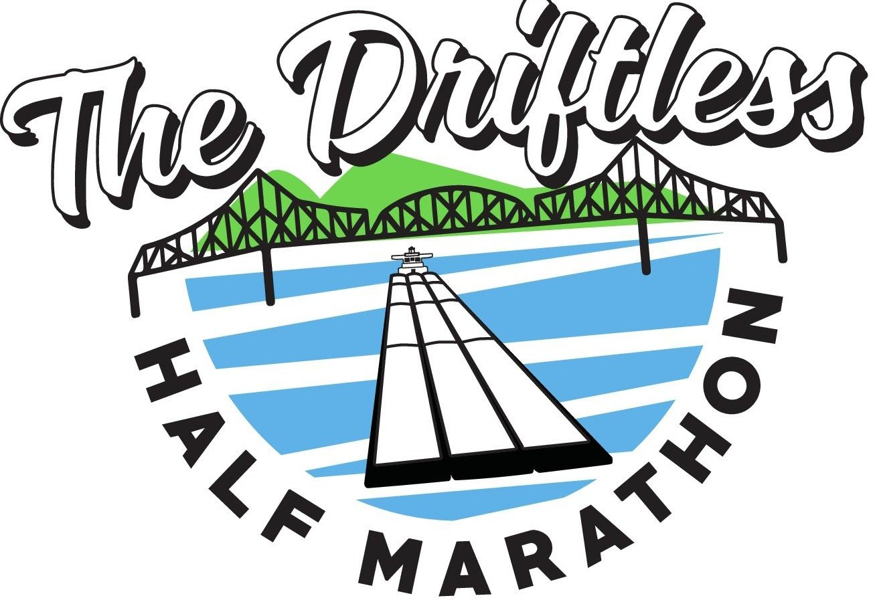

The Driftless Half Marathon Scholarship Application
The Driftless Half Marathon is offering one $500 scholarship to a Waukon High School graduating senior who plans to further their education. This individual should exemplify the spirit of the race by showing passion for hard work, community, health, and charity.

Date:

Name:

Home Address:

City, State, Zip:

E-Mail Address:

Please provide the following items on an additional sheet:

- A typed, one page essay. Include an explanation of why Allamakee County is important to you. Why is it important to give back to the community you call home?
- List any extracurricular activities and experiences (Honor Society, awards, etc.)
- List any out-of-school activities and interests (church, 4-H, volunteer work, employment, etc.)
- List the college or school to which you have been accepted, area of study and start date.

Signature of

applicant: Please email application to thedriftlesshalfmarathon@gmail.com by January 31st

